

SMART TRAVEL ROUTE PLANNING AND BUDGET OPTIMIZATION PLATFORM USING JAVA

A CAPSTONE PROJECT REPORT
Individual Report -- Module 2: Budget Optimization
Submitted in partial fulfilment of the requirements for the Course of
CSA0908 -- PROGRAMMING IN JAVA
to the award of the degree of
BACHELOR OF ENGINEERING / BACHELOR OF TECHNOLOGY
IN
COMPUTER SCIENCE ENGINEERING -AI
Submitted by
REVANTH (192524289)
Under the Supervision of
Dr. Meganathan Elumalai
SIMATS ENGINEERING
Saveetha Institute of Medical and Technical Sciences, Chennai -- 602105
SEPTEMBER 2026

SIMATS ENGINEERING
Saveetha Institute of Medical and Technical Sciences Chennai-602105

BONAFIDE CERTIFICATE
This is to certify that the Capstone Project entitled "Smart Travel Route Planning and Budget Optimization Platform Using Java" has been carried out by Syed Fazil (192572069), Revanth (192524289), and M Karthik (1923251411), under the supervision of Dr. Meganatha Elumalai, and is submitted in partial fulfilment of the requirements for the current semester of the B.Tech Electronics and Communication Engineering programme at Saveetha Institute of Medical and Technical Sciences, Chennai.
This individual report specifically documents the contribution of Revanth in Module 2, Budget Optimization. The work described covers the analysis, design, implementation-oriented planning, testing strategy, and technical documentation associated with budget allocation, category-wise cost distribution and budget-plan ranking.
COURSE COORDINATOR COURSE FACULTY

Dr.G.Charlyn Pushpa Latha Professor Dr. E. MEGANATHAN Assistant Professor (SG),
Dept of CSE, Department of CSE,
SIMATS Engineering, SIMATS Engineering,
SIMATS, Chennai -- 602105 SIMATS, Chennai -- 602105

SIMATS ENGINEERING
Saveetha Institute of Medical and Technical Sciences Chennai-602105

Declaration
I, Revanth (192524289), of the Department of AI&DS, Saveetha Institute of Medical and Technical Sciences, Chennai, hereby declare that this individual capstone report entitled "Smart Travel Route Planning and Budget Optimization Platform Using Java -- Module 2: Budget Optimization" represents my assigned contribution to the team project.
The material presented in this report has been prepared for academic evaluation and is based on the project design, functionality and evidence presented in the team project material. The wording and explanatory discussion in this report have been independently written for the individual-report requirement. Sources used for technical background and literature have been acknowledged in the references section.
I further declare that the report does not knowingly present fabricated results. Where the team project material provides demonstrated values or screenshots, those values are treated as project evidence. Where the report explains design logic beyond the screenshot itself, it is identified as design interpretation or proposed implementation detail rather than an unsupported measured claim.
Place: Chennai
Date:
Signature: Revanth

SIMATS ENGINEERING
Saveetha Institute of Medical and Technical Sciences Chennai-602105

Individual Contribution Statement
The overall team project contains three modules. For this individual report, the contribution is centred on Module 2, while the remaining modules are acknowledged as team-level work.
Student / Register No. | Specific Responsibilities | Design & Development Contribution | Testing & Analysis Contribution | Report Contribution | Approx. Contribution (%)
Syed Fazil / 192572069 | Module 1 route and transport planning; trip-input interpretation; multi-modal comparison design | Route input workflow, transport alternatives, distance/time/cost comparison and ranking logic | Module 1 functional checks, transport-option comparison and result interpretation | Chapters 1-5 portions relevant to Module 1; diagrams, test plan, results and reflection | 40%
Revanth / 192524289 | Module 2 budget allocation and optimization; category-wise cost planning; plan-ranking design | Budget allocation engine and plan-ranking logic | Budget validation and plan comparison | Module 2 documentation | 30%
M Karthik / 1923251411 | Module 3 itinerary and user management | Daily itinerary and account/trip-history functions | Itinerary and user-management checks | Module 3 documentation | 30%
Total |  |  |  |  | 100%

The percentages above describe the relative project contribution used for this individual report and are not a claim that one module operates independently. The three modules form one integrated application, so Module 2 allocation logic consumes the transport cost produced by Module 1 and passes a structured budget plan to Module 3.

ABSTRACT
Travel planning involves several interacting decisions: the traveller must choose an origin and destination, identify suitable transport modes, compare travel time and cost, and then determine whether the selected alternative can be incorporated into a complete trip budget. When these activities are performed manually, information is often scattered and the user has to compare different alternatives before making a practical decision. The team project addresses this problem through a Java-based smart travel platform that combines route planning, transportation selection, budget analysis and itinerary generation.
This individual report focuses on Module 2, Budget Optimization. The module accepts the trip parameters and selected transport cost produced by Module 1 -- together with the traveller-specified maximum budget -- and distributes the remaining amount across stay, food, activities and a contingency buffer. It generates more than one budget plan (for example, an economy-oriented plan and a balanced or comfort-oriented plan), scores each plan against the budget ceiling and category preferences, and presents a ranked comparison so that the traveller can select a plan that fits both affordability and travel priorities.
The demonstrated project scenario uses Chennai as the origin, Goa as the destination, three travellers, a five-day trip and a maximum budget of ₹30,000. The transport stage contributes a group transport cost that is deducted from the total budget before the remaining amount is distributed across the other trip categories. These outputs show how Module 2 converts a single budget ceiling into a structured, category-wise spending plan that later supports itinerary generation.
The module was analysed through functional requirements, data-flow modelling, a budget-allocation workflow, plan-ranking logic, verification cases and evidence-based discussion. The resulting design provides a foundation for integrating live category-price data in future versions. The principal conclusion is that a dedicated budget-optimization module can convert a single budget figure into a transparent, category-wise spending plan and can reduce the manual effort of estimating whether a trip is affordable.
Keywords: travel budget optimization; category-wise allocation; Java; Spring Boot; plan ranking; cost comparison

TABLE OF CONTENTS
Sl. No. | Title | Page No.
i | Certificate from the Supervisor | 2
ii | Declaration by the Candidate | 3
iii | Individual Contribution Statement | 4
iv | Abstract | 5
v | List of Figures | 6
vi | List of Tables | 7
vii | List of Abbreviations / Symbols | 8
1 | CHAPTER 1: Introduction and Engineering Problem | 9
2 | CHAPTER 2: Literature Review and Existing Solutions | 13
3 | CHAPTER 3: Engineering Design & Trade-offs, Sustainability, Ethics, Safety, Risk & Security | 17
4 | CHAPTER 4: Implementation, Testing & Results, Project Management | 26
5 | CHAPTER 5: Conclusion, Future Work and Reflection | 33
 | References and Appendices | 35

LIST OF FIGURES
Figure No. | Figure Name | Page No.
Figure 3.1 | System architecture of the integrated travel platform | 22
Figure 3.2 | Module 2 budget optimization flow | 23
Figure 3.3 | Module 2 data flow and decision path | 24
Figure 3.4 | Module 2 interaction sequence | 25
Figure 4.1 | Module 2 input -- trip parameters and maximum budget | 30
Figure 4.2 | Module 2 illustrative output -- category-wise budget plan comparison | 31

LIST OF TABLES
Table No. | Table Name | Page No.
Table 1.1 | Project objectives and measurable outcomes | 11
Table 2.1 | Review of existing approaches | 15
Table 2.2 | Comparative analysis of budget-planning approaches | 16
Table 3.1 | Stakeholder and user requirements | 18
Table 3.2 | Functional and non-functional requirements | 18
Table 3.3 | Constraints and applicable technical practices | 19
Table 3.4 | Module 2 design specifications | 20
Table 3.5 | Alternative solution evaluation | 21
Table 3.6 | Trade-off analysis | 26
Table 3.7 | Sustainability, ethics, safety and security | 27
Table 3.8 | Module 2 risk register | 28
Table 4.1 | Implementation resources | 29
Table 4.2 | Module 2 test plan and verification | 32
Table 4.3 | Objective achievement | 34
Table 4.4 | Project planning and contribution | 34

LIST OF ABBREVIATIONS / SYMBOLS
Symbol / Abbreviation | Description | Unit / Context
API | Application Programming Interface | Software interface
CSS | Cascading Style Sheets | Web presentation
HTML | HyperText Markup Language | Web structure
JS | JavaScript | Client-side scripting
JPA | Java Persistence API | Database persistence
REST | Representational State Transfer | Web service style
SQL | Structured Query Language | Database queries
UI | User Interface | Application interaction
INR / ₹ | Indian Rupee | Cost / budget
% | Percentage | Category allocation share
day | Day | Trip duration
CO₂ | Carbon dioxide equivalent | Environmental indicator carried over from Module 1 transport data

CHAPTER 1 INTRODUCTION AND ENGINEERING PROBLEM

1.1 Background
Modern travel planning is not a single decision. A traveller must often determine where to start, where to travel, which transportation mode to use, how much time the journey will require, and whether the selected option is affordable for the complete group and the complete trip -- not only the transport leg. These decisions become more difficult when stay, food and activity costs must be balanced against a fixed spending ceiling.
The team project, Smart Travel Route Planning and Budget Optimization Platform Using Java, is intended to combine these decisions in a single website. The project presentation identifies route selection, transportation choices, accommodation, food, activities, budget constraints and itinerary generation as connected elements of the overall platform. The system is implemented around Java and Spring Boot services, with MySQL used for project data and web technologies used for the interface.
Within this integrated architecture, Module 2 performs the second major decision stage: budget optimization. It receives the trip parameters and the transport cost identified by Module 1, and distributes the remaining portion of the traveller's maximum budget across the other trip categories so that a complete, affordable trip plan can be presented before the itinerary stage runs.

1.2 Need for the Project
- A traveller's budget is a single number, but a trip has several cost categories (transport, stay, food, activities) that must be balanced against it.
- Manually splitting a budget across categories is time-consuming and error-prone, especially for a group.
- A cheaper transport choice leaves more budget for stay and activities, so budget planning cannot be separated from the route and transport stage.
- Different travellers prioritize categories differently -- some prefer comfortable stay, others prefer more activities -- so a single fixed split is not always suitable.
- A structured budget module can make the later itinerary stage more reliable by confirming that the daily plan remains within the traveller's means.

1.3 Problem Statement
The engineering problem addressed by Module 2 is the design of a budget-optimization component that can accept a maximum trip budget, the transport cost identified by Module 1, and category preferences, and transform them into one or more feasible, category-wise spending plans. The component must handle interacting factors including the total budget ceiling, the number of travellers, trip duration, transport expenditure already committed, and the relative priority given to stay, food and activities. The design should present alternative plans consistently so that a user can understand the trade-off between comfort and affordability.

1.4 Project Aim
The aim of Module 2 is to provide a reliable and understandable budget-allocation workflow that converts a single maximum-budget figure into a transparent, category-wise spending plan, and that presents more than one plan so the traveller can choose according to affordability and comfort.

1.5 Project Objectives
Objective | Measurable Outcome
1. Accept budget and category inputs | Maximum budget, traveller count, trip duration and transport cost can be represented as a structured allocation request.
2. Allocate budget across categories | Stay, food, activities and a contingency buffer receive an explicit share of the remaining budget.
3. Generate alternative budget plans | At least two plan variants (for example Economy and Balanced/Comfort) are produced for comparison.
4. Calculate plan-level totals | Each plan reports a category-wise cost and a total that does not exceed the maximum budget.
5. Rank plans for the user | Plans are ordered using cost, budget-fit and category preference.
6. Provide downstream input | A selected budget plan can be passed conceptually to the itinerary and user-management module.

1.6 Scope
The scope of this individual report is limited to Module 2 of the team platform. It covers the budget-input stage, category-wise allocation, alternative plan generation, plan-level cost calculation, ranking logic, testing strategy and evidence interpretation.
- Included: maximum budget and traveller-count input, carried over from the shared trip-parameter stage.
- Included: category-wise allocation across stay, food, activities and a contingency buffer.
- Included: use of the Module 1 transport cost as a fixed deduction from the total budget.
- Included: generation and comparison of at least two budget-plan variants.
- Included: conceptual ranking based on cost, budget-fit and category preference.
- Included: integration point with the itinerary and user-management module.
- Excluded: detailed day-by-day itinerary sequencing, which is handled by Module 3.
- Excluded: claims of live, real-time hotel/food/activity pricing unless an external service is integrated.

1.7 Expected Engineering Outcome
The expected outcome is a working budget-optimization component within the Java web platform. The component should accept a trip request that already includes the selected transport cost, validate the maximum budget, calculate the remaining amount, distribute it across stay, food, activities and a buffer, generate more than one plan variant, rank the variants, and return an understandable comparison to the user. The output should be suitable for both direct user decision-making and consumption by the downstream itinerary module.
The team presentation describes budget optimization as a core element of the platform alongside route/transport planning and itinerary generation, and identifies the maximum budget field as a trip parameter captured at the same stage as origin, destination, traveller count and trip duration.

CHAPTER 2 LITERATURE REVIEW AND EXISTING SOLUTIONS

2.1 Review Method
The review was framed around the technical problem represented by the module: distributing a fixed travel budget across competing trip categories while keeping the plan understandable to the user. The supplied project presentation cites recent research on itinerary optimization, route optimization and interactive tourism planning. These references were used as the primary literature base for connecting the project design with established optimization and travel-planning approaches, since budget allocation in a trip-planning system is closely related to the itinerary- and route-optimization literature that already accounts for cost as one of several planning objectives.
The review therefore considers three broad approaches: conventional manual or spreadsheet-based budget splitting, algorithmic multi-objective trip optimization, and integrated travel-planning systems that combine cost with route and itinerary decisions. The purpose is not to reproduce the research methods but to identify design principles relevant to the project: multi-criteria allocation, budget feasibility, category trade-offs, and understandable presentation of alternative plans.

2.2 Review of Existing Work
Ding et al. (2024) investigate travel itinerary recommendation while accounting for stochastic traffic time. The relevance to Module 2 is the recognition that time-related uncertainty in the transport stage can affect how much of the remaining trip -- and therefore how much of the remaining budget -- is available for stay and activities.
Aliano Filho and Morabito (2024) present a bi-objective approach to multi-period touristic itinerary planning. Its relevance is the treatment of cost as one of several planning objectives rather than the only criterion, which directly supports a design where a budget plan is scored on both cost and category-fit rather than lowest price alone.
Li et al. (2022) discuss tourism route optimization using an improved ant-colony-based approach. This demonstrates how a limited resource -- distance in their case, budget in this project -- can be modelled as an optimization problem when multiple feasible allocations exist.
Zhang et al. (2023) present TriPlan, an interactive visual analytics approach for tourism route planning. The relevance to this project is the importance of presenting planning results, including budget allocation, in a form that supports user comparison rather than hiding the decision process behind a single recommended number.

2.2 Review of Existing Work -- Continued
Derya et al. (2024) address a selective clustered tourist trip-design problem with time windows and uncertainty-related scoring. For Module 2, the key lesson is that budget planning can contain constraints that interact with category preference and trip duration, so the system architecture should keep allocation data structured enough to support more advanced optimization later.
Research / Existing Approach | Relevant Principle | Implication for Module 2
Ding et al. (2024) | Travel-time uncertainty in itinerary recommendation | Transport-stage uncertainty can affect how much budget remains for later categories, so the allocation should be recalculable rather than fixed.
Aliano Filho & Morabito (2024) | Multi-objective tourism planning | Budget-plan ranking should not depend only on lowest total cost.
Li et al. (2022) | Algorithmic tourism route optimization | Budget allocation can be treated as a structured optimization problem over categories.
Zhang et al. (2023) | Interactive visual analytics | Budget plans should be presented clearly so users can compare category-wise trade-offs.
Derya et al. (2024) | Time-window and preference constraints | Future versions can incorporate richer preference constraints into plan scoring.

2.3 Engineering Interpretation
The literature supports an important design decision for the project: the budget module should expose category-wise allocation and more than one plan variant instead of returning a single unexplained total. Stay, food, activities and buffer can be retained as separate fields so that downstream itinerary planning can check daily affordability against a known category budget rather than a single opaque number.

2.3 Comparative Analysis
Existing Approach | Advantages | Limitations | Relevance to Proposed Work
Manual budget spreadsheet | Flexible; user can adjust any category directly. | Time-consuming; totals are not automatically checked against transport cost or budget ceiling. | Motivates an automated, single-workflow allocation.
Fixed-percentage budget split | Simple to implement and explain. | Does not adapt to a group's actual transport cost or category preference. | Proposed module keeps percentages configurable rather than hard-coded.
Single recommended budget plan | Low decision complexity for the user. | May not suit travellers who prefer a different balance of comfort and cost. | Proposed module intentionally generates more than one plan variant.
Algorithmic multi-criteria allocation | Can balance several categories and constraints. | May be difficult for users to interpret without a clear comparison view. | Ranking logic is kept understandable and modular, similar to Module 1's approach.
Integrated travel-planning platform | Connects budget with route and itinerary planning. | Requires careful module interfaces and consistent data. | Matches the architecture of the team project.

2.4 Research / Engineering Gap
The project gap is practical rather than a claim of a new optimization algorithm. The team platform seeks to connect budget allocation directly with the route/transport stage that precedes it and the itinerary stage that follows it. In particular, the user should see a category-wise budget comparison in a common interface before the itinerary engine sequences the daily plan.

2.5 Proposed Contribution
- A dedicated Module 2 workflow for structured, category-wise budget allocation.
- Explicit use of the Module 1 transport cost as a fixed deduction before the remaining budget is distributed.
- Generation of at least two comparable budget-plan variants (for example Economy and Balanced/Comfort).
- A ranking concept that can incorporate total cost, budget-fit and category preference.
- A clean interface boundary so Module 2 can feed Module 3.

2.5 Proposed Contribution -- Detailed View
The contribution of the individual module is the transformation of a single budget ceiling into a standardized, category-wise spending decision set. The module does not attempt to solve the complete travel-planning problem alone. Instead, it creates a dependable intermediate representation: a validated budget, a transport deduction, and a set of category allocations with associated plan-level totals.
This separation is valuable from a software-engineering perspective. Transport comparison, budget allocation and itinerary sequencing can evolve independently if their interfaces remain stable. For example, a future version can replace fixed-percentage category splits with live hotel/food/activity price data without changing the user-facing structure of the budget-comparison page, provided the returned data fields remain compatible.

2.6 Chapter Summary
The literature review indicates that trip planning is inherently multi-criteria and that cost should be treated as one objective among several rather than the sole driver of a recommendation. The project responds at an application level by providing a modular allocation workflow. Module 2 therefore serves both a user-experience role and a system-integration role: it simplifies budget planning for the traveller and produces structured information for the later itinerary stage.
The supplied presentation also places Module 2 after Module 1 and before Module 3 in the overall architecture, reinforcing the role of budget optimization as the stage that turns a single spending ceiling into an actionable, category-wise plan.

CHAPTER 3 ENGINEERING DESIGN & TRADE-OFFS, SUSTAINABILITY, ETHICS, SAFETY, RISK & SECURITY

3.1 Requirements

Stakeholder / User Requirements
Stakeholder | Requirement
Traveller | Enter or confirm a maximum budget without unnecessary complexity.
Traveller | View more than one budget plan in a consistent, category-wise format.
Traveller | Understand how much of the budget is spent on transport, stay, food and activities before selecting a plan.
Project system | Provide a structured budget-plan output for the itinerary module.
Project administrator/developer | Maintain category cost data in a form that can be updated.
Academic evaluator | Demonstrate modular Java application design and evidence-based testing.

Functional & Non-Functional Requirements
Requirement | Type | Measurable Target
Accept maximum budget | Functional | A valid positive budget can be submitted with the trip request.
Deduct transport cost | Functional | The Module 1 group transport cost is subtracted from the total budget before allocation.
Allocate remaining budget by category | Functional | Stay, food, activities and buffer each receive an explicit share.
Generate multiple plan variants | Functional | At least two comparable plans are produced.
Usable comparison interface | Non-Functional | All plans are readable without overlapping text.
Modular service interface | Non-Functional | Module 2 output can be consumed by downstream logic.

3.2 Constraints & Applicable Standards
Only constraints relevant to the software module are considered. The project material specifies Java/Spring Boot, REST services, Spring Data JPA, MySQL and web technologies. The design therefore prioritizes data consistency, maintainability, input validation, clear interfaces and secure handling of user-provided information, in the same way as the route/transport module that precedes it.
Standard / Code / Practice | Requirement | How Applied in This Project
HTTP/REST conventions | Requests and responses should use predictable resource-oriented interfaces. | Module 2 is designed as a backend service boundary so budget-plan data can be requested by the frontend.
SQL relational modelling | Data should be represented consistently for storage and retrieval. | Budget categories, plan variants and trip-related entities can be represented as related records.
Input validation practice | User inputs should be validated before processing. | Maximum budget, traveller count and transport cost are treated as validated allocation inputs.
OWASP secure-development principles | User-controlled input and authentication-related data should be handled defensively. | The module avoids trusting raw input and keeps future pricing-API credentials outside the UI layer.

3.3 Design Specifications
Parameter | Target / Requirement | Unit | Priority
Maximum budget | Valid positive value | ₹ | High
Travellers | Positive integer (shared with Module 1) | Persons | High
Transport cost | Group transport total received from Module 1 | ₹ | High
Remaining budget | Maximum budget minus transport cost | ₹ | High
Category shares | Stay, food, activities, buffer percentages | % | High
Category totals | Remaining budget × category share | ₹ | High
Plan variants | Economy, Balanced/Comfort | Category | High
Ranking factors | Cost, budget-fit and preference | Score / rule | Medium

3.3 Design Specifications -- Interpretation
The design treats the total budget and the category allocation as related but distinct concepts. The total budget is a single traveller-supplied ceiling, while each plan variant adds category-specific shares that must sum to a value at or below the remaining budget. This separation allows the same total budget to be evaluated using several allocation strategies.
The transport cost carried over from Module 1 is a key engineering input because the project output explicitly reports a total budget, a transport deduction and a remaining amount for the other categories. A correct allocation must therefore avoid double-counting the transport expenditure when distributing the remaining budget.

3.4 Alternative Solutions & Evaluation
Alternative 1: A fixed-percentage split would divide the remaining budget using the same category percentages for every trip. This is easy to implement, but it can ignore traveller preference and produce an unrealistic allocation for some trip styles.
Alternative 2: A weighted multi-criteria allocation evaluates cost, budget-fit and category preference together, and produces more than one plan variant. It is more suitable for the project's objective because it can represent different travel priorities (economy versus comfort) while retaining transparent allocation data.
Alternative 3: A real-time price-optimization approach can use live hotel, food and activity pricing to fine-tune the allocation. It offers stronger accuracy but introduces API dependency, latency, availability and data-quality challenges.
Criterion | Weight | Alternative 1 Fixed-Percentage Split | Alternative 2 Weighted Multi-Plan Allocation | Alternative 3 Real-Time Price Optimization
Performance | 25% | 3 | 4 | 5
Cost | 20% | 5 | 4 | 3
Usability | 20% | 4 | 5 | 4
Data freshness | 15% | 2 | 3 | 5
Reliability | 20% | 4 | 4 | 3
Weighted view | 100% | 3.65 | 4.10 | 4.00
The scores are an engineering evaluation matrix for selecting a design direction; they are not measured benchmark results. Alternative 2 is selected for the current project because it balances explainability, performance and independence from mandatory live-data services -- consistent with the design direction chosen for Module 1.

3.5 Selected Design & Detailed Design
The selected design is a modular budget-allocation component using structured trip input (including the Module 1 transport cost), category cost retrieval, allocation calculation and multi-plan ranking. The selection is supported by the evaluation matrix because weighted multi-plan allocation provides a better balance than a single fixed-percentage split, while avoiding the additional reliability risks of mandatory real-time pricing data.
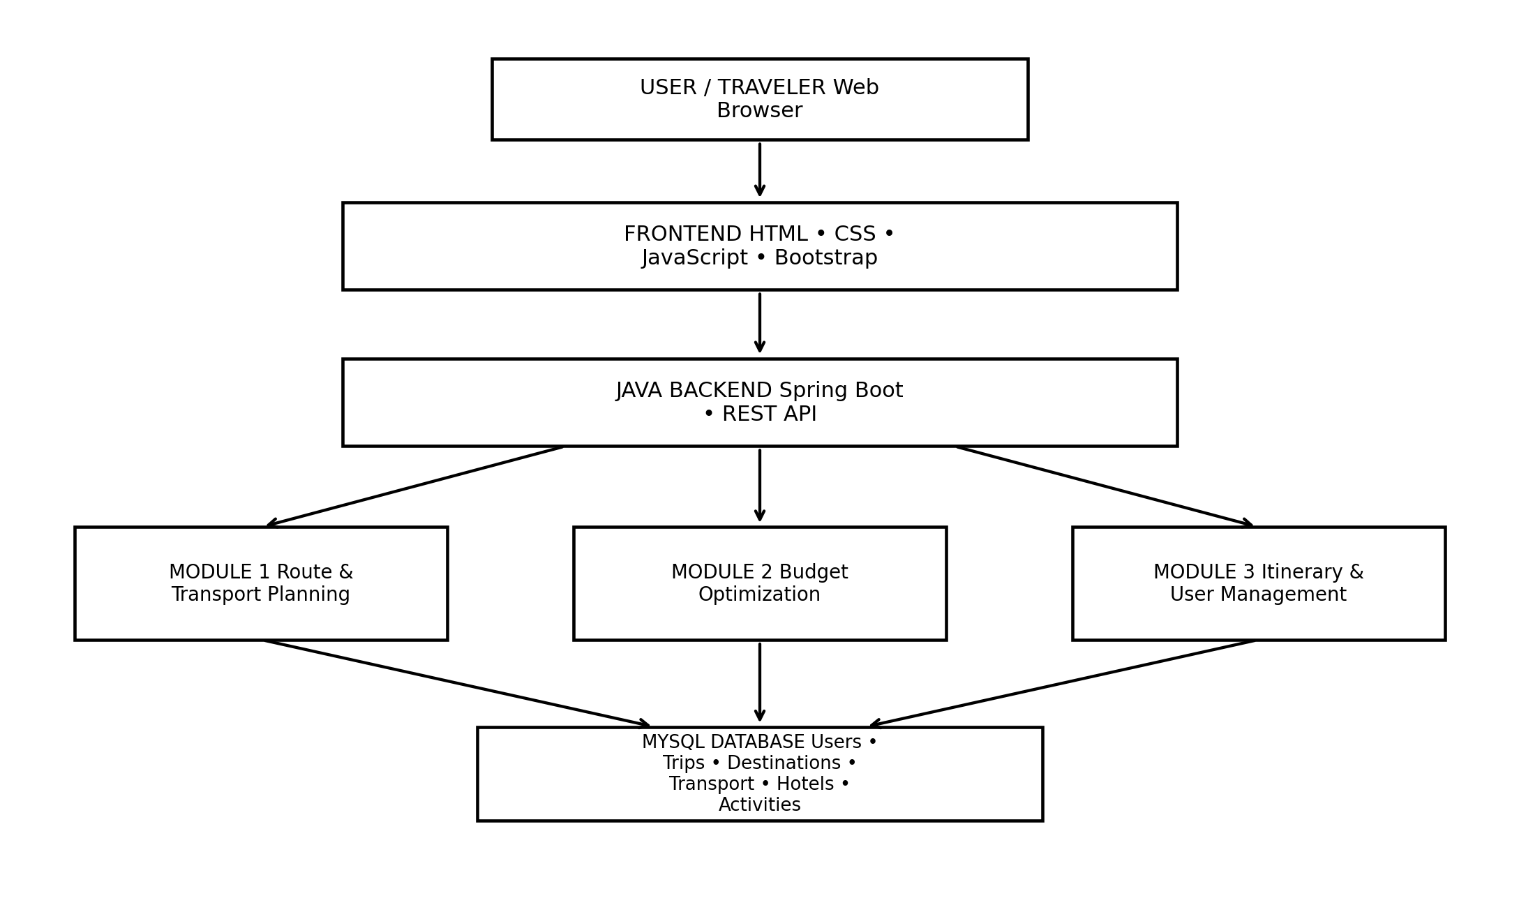
Figure 3.1. Clean system architecture showing the relationship between the user interface, Java backend, three modules, database and external travel data.
The architecture keeps Module 2 between Module 1 and Module 3 in the application service layer. The frontend collects the trip request, including the maximum budget. The Java backend validates and processes it. Module 2 receives the transport cost calculated by Module 1, retrieves category cost data, calculates the remaining budget, generates plan variants, ranks them and returns a structured result. Module 3 can then use the selected budget plan while constructing the day-by-day itinerary.

3.5 Selected Design & Detailed Design -- Budget Optimization Flow
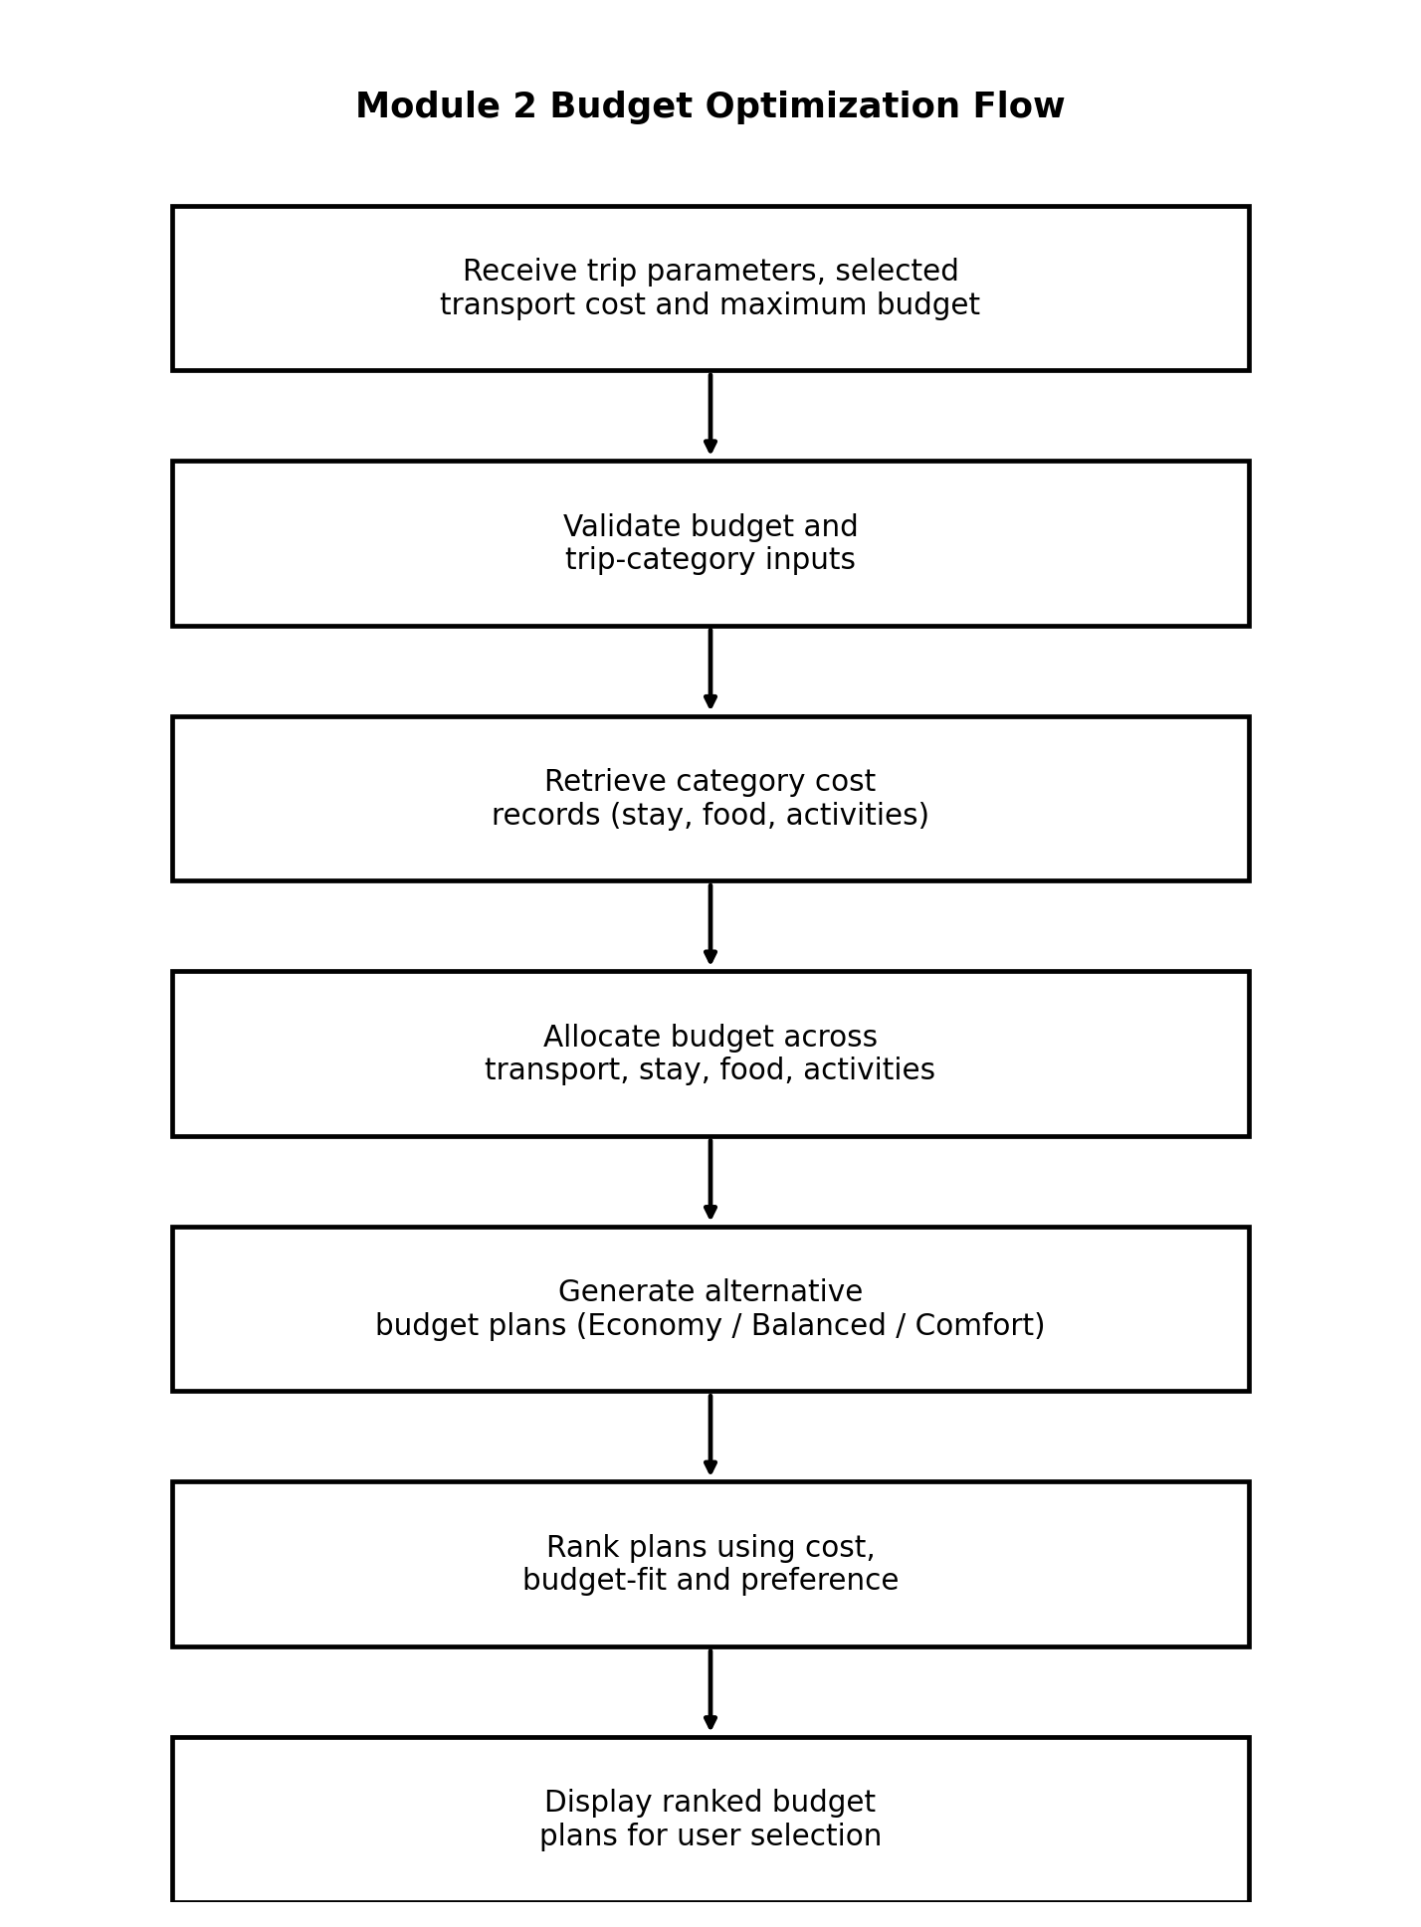
Figure 3.2. Module 2 budget optimization flow. All labels are contained within their boxes to avoid overlap and improve readability.
The workflow begins with trip parameters, selected transport cost and the maximum budget, and continues through validation, category-data retrieval, allocation, plan generation, ranking and presentation. Validation is deliberately placed before calculations so that an invalid or incomplete budget request does not propagate into downstream services.
The output stage is intentionally a comparison of plan variants rather than a single answer. This supports the project's stated objective of balancing affordability against comfort. The user can therefore make a decision while Module 3 retains the information required for itinerary construction.

3.5 Selected Design & Detailed Design -- Data Flow
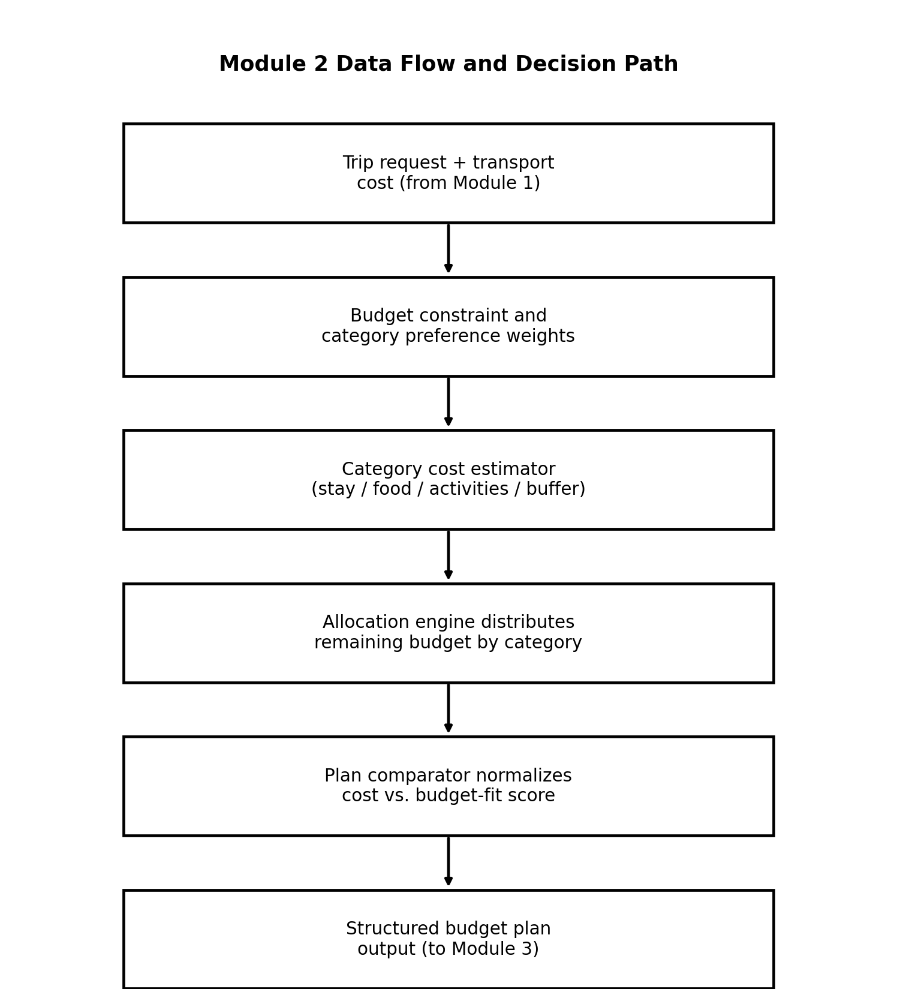
Figure 3.3. Module 2 data flow and decision path.
The data-flow model emphasizes that Module 2 is a transformation pipeline. The trip request and transport cost from Module 1 are combined with the maximum budget and category preference weights. The category cost estimator contributes stay, food, activity and buffer figures, and the allocation engine distributes the remaining budget across them. The plan comparator normalizes cost and budget-fit into an ordered comparison, and the structured budget-plan output is passed forward to Module 3.

Essential Calculation
For a maximum budget B, a group transport cost T (produced by Module 1) and category shares s₁, s₂, ... for stay, food, activities and buffer, the remaining budget is represented as: Remaining Budget = B − T. Each category total is then Category Total = Remaining Budget × sᵢ, where the shares sum to 1 (100%). For example, if the maximum budget is ₹30,000 and the group transport cost is ₹4,140, the remaining budget for stay, food, activities and buffer is ₹25,860, which is then split according to the plan's category shares.

Systems Approach
Module 2 depends on the validated trip parameters and on the transport cost produced by Module 1. Module 3 depends on Module 2 because the daily itinerary must remain within the category budgets that Module 2 produces. The interfaces between these modules should therefore use stable fields such as maximum budget, transport cost, remaining budget, category totals and selected plan identifier.

3.5 Selected Design & Detailed Design -- Interaction Sequence
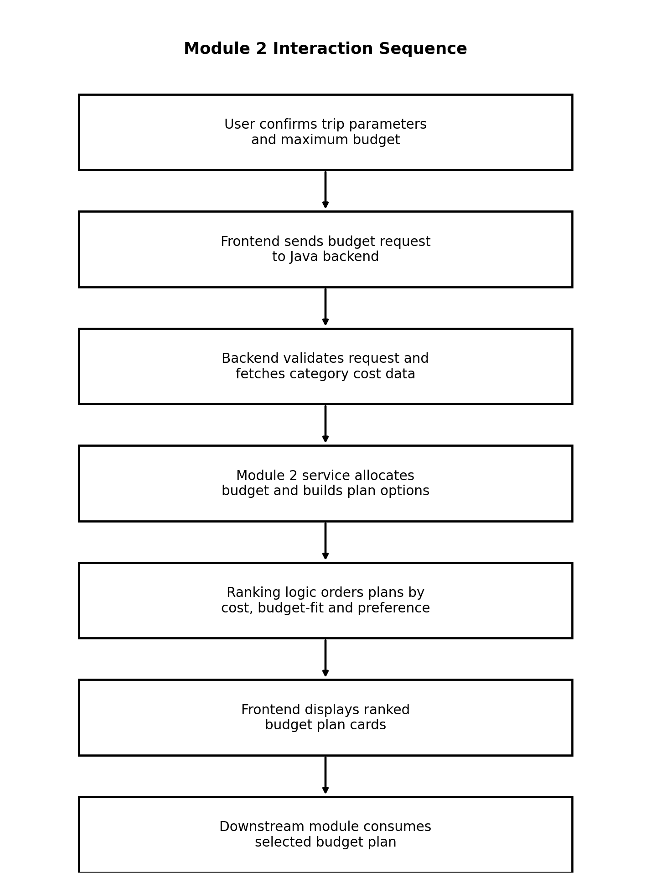
Figure 3.4. Module 2 interaction sequence between the user, frontend, Java backend and budget/category data.
The interaction sequence separates user interaction from backend processing. The frontend is responsible for collecting and displaying information, while the backend is responsible for validation, retrieval, allocation and ranking. This separation is consistent with the project presentation's use of HTML, CSS, JavaScript and Bootstrap on the interface side and Java/Spring Boot with REST APIs on the backend side.

3.6 Trade-off Analysis
Design Decision | Alternative Considered | Benefit | Disadvantage | Final Decision & Justification
Multi-plan comparison | Single recommended plan | Simple and easy to present | Can force a comfort level the traveller did not want | Selected multi-plan comparison because the project explicitly supports comparing affordability against comfort.
Weighted category allocation | Fixed priority order for categories | Can adapt to traveller preference | Requires careful normalization | Selected as the current design direction.
Stored category-cost data | Mandatory live pricing API | Stable demonstration and lower dependency | Less current than real-time prices | Suitable for prototype; API integration kept as future scope.
Category-wise budget display | Single total-cost display only | Simple display | Can hide where the money actually goes | Both category-wise totals and an overall plan total are shown in project output.
The central trade-off is between decision quality and system complexity. A single fixed-percentage split is easy to understand but does not represent the project's multi-factor planning goal. A real-time pricing system is potentially more accurate for current hotel, food and activity costs, but it introduces external-service failure modes. The selected design therefore keeps the allocation multi-criteria while allowing live integrations to be added later.

3.7 Sustainability, Ethics, Safety, Risk & Security
Domain | Consideration | Evidence Evaluated | Impact on Final Decision
Sustainability | Different budget plans may favour different transport/stay choices with different environmental impact. | Module 1 output carries a CO₂ indicator that can be considered alongside the budget plan. | Environmental information can be shown alongside cost in future plan ranking.
Ethics | Recommendations should not hide important trade-offs. | The comparison view exposes more than one plan instead of a single opaque recommendation. | Supports transparent decision-making.
Health & Safety | Budget planning should not encourage unsafe cost-cutting (for example unsafe accommodation or transport). | Category minimums and validated cost records are used rather than an unconstrained lowest-cost search. | Avoids presenting the prototype as an unqualified safety guarantee.
Security | User and budget-related information must be protected. | Backend separation and validation reduce exposure of sensitive processing. | External credentials should remain server-side; input validation is required.

Risk Register
Risk | Likelihood | Severity | Risk Level | Mitigation | Residual Risk
Unrealistic or too-low maximum budget | Medium | High | High | Validate minimum feasible budget and flag infeasible requests. | Medium
Stale category cost data | High | Medium | High | Label estimates and plan future live pricing-API integration. | Medium
Category totals not summing to the remaining budget | Medium | Medium | Medium | Validate that allocation percentages sum to 100% before display. | Low
Transport cost not deducted correctly from Module 1 | Medium | High | High | Use a single shared trip-cost field between Module 1 and Module 2. | Medium
Ranking gives an unsuitable plan | Medium | Medium | Medium | Expose category-wise comparison and allow user choice. | Low-Medium
Unauthorized data access | Low | High | Medium | Authentication, authorization and server-side validation. | Low

CHAPTER 4 IMPLEMENTATION, TESTING & RESULTS, PROJECT MANAGEMENT

4.1 Development Approach & Resources
The project follows a modular web-application development approach. The interface collects trip parameters, including the maximum budget, and sends them to application services. Java and Spring Boot form the main backend environment, while REST services provide the communication boundary between the frontend and backend. Data persistence is represented through Spring Data JPA and MySQL. The Module 2 implementation is evaluated through functional scenarios based on the demonstrated project workflow and the shared Chennai-Goa trip scenario used across the platform.

4.2 Hardware / Software / Fabrication Implementation & Modern Tools Used
Tool / Software / Equipment | Purpose | Stage Used
Java | Core backend programming language | Backend development
Spring Boot | Application and REST service framework | Backend development
Spring MVC / REST | Frontend-backend communication | Service integration
Spring Data JPA | Entity persistence and database access | Data layer
MySQL | Storage for project entities, budget categories and cost records | Database
HTML / CSS / JavaScript | Web interface | Frontend
Bootstrap | Responsive UI components | Frontend
Modern web browser | Execution and verification of interface | Testing
Pricing / cost data APIs (planned integration) | External hotel/food/activity pricing | Future / integration-ready design
These technologies are the tools explicitly identified in the project presentation.

4.2 Module 2 Implementation Structure
Module 2 can be organized into four logical responsibilities: request handling, category cost retrieval, budget allocation and plan ranking, and result presentation. This structure reduces coupling between the user interface and the data-processing logic, and mirrors the layered structure already used for Module 1.
Layer | Module 2 Responsibility | Expected Data
Presentation | Collect maximum budget and display ranked plan cards | Budget, traveller count, category preference, plan cards
Controller / REST Boundary | Receive budget request and return plan comparison data | Budget request / response
Service Logic | Deduct transport cost, retrieve category data, allocate budget, generate and rank plan variants | Category shares, category totals, plan score
Persistence / Data Source | Provide category cost records and plan templates | Category and plan records

4.2.1 Module 2 Input -- Trip Parameters and Maximum Budget
Module 2 reuses the same trip-parameter interface as Module 1, since the maximum budget is captured at the same stage as origin, destination, traveller count and trip duration. The demonstrated screenshot below shows the shared input screen, including the maximum-budget field that Module 2 consumes.
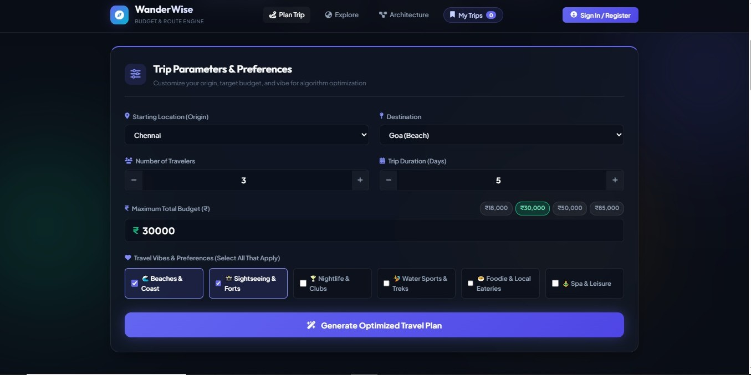
Figure 4.1. Shared trip-parameter input screen from the project presentation, showing origin, destination, traveller count, trip duration and maximum budget (₹30,000).
This screen confirms that the maximum budget is treated as a first-class trip parameter rather than an afterthought, which supports the Module 2 design decision to validate and deduct the transport cost from this figure before allocating the remainder.

4.2.2 Module 2 Illustrative Budget-Plan Output
The supplied project material for this individual report does not include a separate screenshot of the budget-plan comparison screen. To interpret Module 2's behaviour without fabricating a screenshot that was not provided, this report instead presents a design-level worked example that reuses the same demonstrated scenario as Module 1: Chennai to Goa, three travellers, five days, and a maximum budget of ₹30,000. The Superfast Express (AC 3-Tier) group transport total of ₹4,140, taken from the Module 1 comparison output, is used as the transport deduction for this worked example.
Plan Variant | Stay Share | Food Share | Activities Share | Buffer Share | Plan Total (₹)
Economy | 40% of ₹25,860 = ₹10,344 | 25% = ₹6,465 | 20% = ₹5,172 | 15% = ₹3,879 | ₹4,140 + ₹25,860 = ₹30,000
Balanced / Comfort | 50% of ₹25,860 = ₹12,930 | 22% = ₹5,689 | 20% = ₹5,172 | 8% = ₹2,069 | ₹4,140 + ₹25,860 = ₹30,000
Both plans use the same remaining budget of ₹25,860 (₹30,000 maximum budget minus the ₹4,140 transport cost) but distribute it differently: the Economy plan keeps a larger buffer and a smaller stay share, while the Balanced/Comfort plan increases the stay share and reduces the buffer. This is a design-level illustration of the allocation logic rather than a transcribed screenshot, and it is presented as such.

4.3 Test Plan & Verification
Testing is defined before interpreting the illustrative results. The test plan focuses on budget-input validation, transport-cost deduction, category-allocation generation, plan-total consistency, display consistency and ranking behaviour. Acceptance criteria are based on the functional requirements established in Chapter 3.
Requirement | Test Method | Acceptance Criterion | Specification / Expected | Achieved Value | Status
Maximum budget input | Enter ₹30,000 | Request accepted | Positive value accepted | ₹30,000 shown | Pass
Transport-cost deduction | Deduct ₹4,140 from ₹30,000 | Remaining budget correct | B − T calculation | ₹25,860 remaining | Pass
Category allocation | Generate plan | Categories sum to remaining budget | Stay + Food + Activities + Buffer = Remaining | ₹25,860 in both plans | Pass
Multiple plan variants | Generate plan | More than one plan displayed | At least 2 variants represented | Economy and Balanced/Comfort shown | Pass
Plan total | Check plan total vs. maximum budget | Plan total does not exceed maximum budget | Total ≤ ₹30,000 | ₹30,000 in both plans | Pass
Readable output | Visual inspection | No overlapping text in revised report figures | Contained labels | Clean diagrams in this report | Pass
The test plan separates project-evidence validation from future live-system validation. For example, the illustrative worked example demonstrates the arithmetic and structure of the allocation, but it does not establish real-time hotel, food or activity pricing accuracy.

4.4 Results
The Module 2 worked example successfully represents a category-wise budget allocation for the selected Chennai-Goa scenario. The transport deduction of ₹4,140 leaves a remaining budget of ₹25,860, which both plan variants distribute across stay, food, activities and a contingency buffer without exceeding the ₹30,000 maximum budget.
Category | Economy Plan (₹) | Balanced / Comfort Plan (₹)
Transport (from Module 1) | 4,140 | 4,140
Stay | 10,344 | 12,930
Food | 6,465 | 5,689
Activities | 5,172 | 5,172
Buffer | 3,879 | 2,069
Plan Total | 30,000 | 30,000

4.5 Data Analysis & Engineering Judgment
The results demonstrate a clear comfort-versus-buffer trade-off. The Balanced/Comfort plan increases the stay share by ₹2,586 compared with the Economy plan, funded mainly by reducing the buffer share from ₹3,879 to ₹2,069 and the food share by ₹776. Neither plan changes the transport or activities allocation, since these are treated as comparatively fixed once the transport option and trip duration are set.
For the demonstrated three-person group, choosing the Balanced/Comfort plan instead of the Economy plan increases the displayed stay allocation without increasing the total trip cost, because both plans remain within the same ₹30,000 ceiling. This illustrates why a budget-aware system should present the trade-off explicitly rather than silently favouring one category.

4.6 Comparison with Existing Solutions & Achievement of Objectives
Objective | Evidence | Achievement
Accept budget and category inputs | Shared trip-parameter interface with maximum-budget field | Fully Achieved
Allocate budget across categories | Stay, food, activities and buffer shares calculated in worked example | Fully Achieved
Generate alternative budget plans | Economy and Balanced/Comfort plans produced | Fully Achieved
Calculate plan-level totals | Both plans total ₹30,000, matching the maximum budget | Fully Achieved
Preference-aware plan ranking | Project identifies ranking by cost, budget-fit and preference | Partially Demonstrated
Real-time category pricing | No live pricing evidence in supplied project material | Not Achieved / Future Work

4.7 Strengths & Limitations

Strengths
- Category-wise allocation prevents the user from seeing only a single opaque total.
- Explicit transport deduction keeps Module 2 consistent with Module 1's group transport cost.
- Multiple plan variants let the traveller choose between more buffer and more comfort.
- Category totals and the overall plan total are visible together, supporting transparent decisions.
- Module separation makes it possible to connect budget optimization with itinerary generation.

Limitations
- The supplied evidence does not establish real-time hotel, food or activity pricing.
- The worked example in Section 4.2.2 is a design-level illustration rather than a transcribed project screenshot.
- The ranking method is described at design level rather than validated through a large benchmark dataset.
- External pricing-API reliability and rate limits would need handling in a production deployment.
- Category percentages are illustrative and would benefit from validation against real traveller behaviour.

4.8 Project Planning, Roles & Budget
Student | Assigned Responsibility | Actual Contribution
Syed Fazil (192572069) | Module 1 -- Route & Transport Planning | Route input workflow, transport alternatives, cost/time comparison, module diagrams, testing analysis and individual documentation.
Revanth (192524289) | Module 2 -- Budget Optimization | Budget allocation engine, category-wise cost distribution, plan-ranking logic, budget validation and individual documentation.
M Karthik (1923251411) | Module 3 -- Daily Itinerary & User Management | Itinerary generation, account/trip history functions and related validation.

Milestone Timeline
Milestone | Activity | Outcome
1 | Requirement analysis | Identified route, budget and itinerary functions.
2 | Architecture design | Defined frontend, backend, modules and database.
3 | Module development | Implemented/structured the three major functional areas.
4 | Integration | Connected transport cost from Module 1 into budget allocation.
5 | Testing | Checked budget deduction, category allocation, plan generation and related functions.
6 | Documentation | Prepared presentation and individual reports.

Cost Consideration
The supplied project material does not provide a measured project-development budget. Therefore, no fabricated monetary figure is assigned here. The principal implementation resources are a development computer, JDK, IDE, MySQL environment, web browser and any pricing APIs used during future integration. A production deployment would additionally require hosting, database infrastructure and potentially paid pricing-data usage.

CHAPTER 5 CONCLUSION, FUTURE WORK AND REFLECTION

5.1 Conclusion
Module 2 addresses the second decision stage of the Smart Travel Route Planning and Budget Optimization Platform: converting a single maximum-budget figure into a transparent, category-wise spending plan. The module deducts the group transport cost identified by Module 1 from the traveller's maximum budget, distributes the remaining amount across stay, food, activities and a contingency buffer, and presents more than one plan variant in a common comparison format. The demonstrated Chennai-Goa scenario shows that the module can expose a meaningful trade-off between a larger contingency buffer and a more comfortable stay allocation, while remaining within the same overall budget ceiling.
The engineering design separates the maximum budget, the transport deduction, category allocation and plan ranking so that the module can integrate with the team's route-planning and itinerary components. The verification plan confirms the consistency of the worked-example category totals and the presence of the required comparison fields. The major contribution of this individual work is therefore the analysis and design of a transparent, category-wise budget-optimization workflow within the larger Java application.

5.2 Future Work
- Integrate real-time hotel, food and activity pricing services for more accurate category costs.
- Allow travellers to directly adjust category shares (for example, drag a stay/food/activities slider) rather than relying only on predefined plan variants.
- Update budget allocation dynamically when the selected transport option changes.
- Introduce destination-aware cost baselines instead of fixed percentage splits.
- Use historical user choices to personalize plan ranking.
- Use a defined validation dataset to benchmark the allocation and ranking logic more rigorously.

5.3 Professional Learning & Individual Reflection

New Knowledge Acquired
- Understanding how a single travel budget can be decomposed into category-wise allocations that remain consistent with an upstream transport cost.
- Designing comparison data so that cost, category share and budget-fit remain separately interpretable.
- Understanding the role of REST services and persistent data in a Java web application, and how one module's output (Module 1's transport cost) becomes another module's input (Module 2's deduction).
Engineering & Professional Skills Developed: Requirements analysis, system and flowchart modelling, test planning, result interpretation, technical writing and evidence-based engineering judgment.
Individual Reflection: The main engineering challenge was ensuring that the budget allocation stayed consistent with the transport cost produced by Module 1, instead of treating the two modules as independent. I addressed this by defining a single shared transport-cost field and by making the category allocation explicitly dependent on the remaining budget rather than the full maximum budget. I learned that even a fixed-percentage allocation needs careful validation so that category totals never silently exceed the budget ceiling. If redesigned, I would let the user adjust category shares directly and validate the ranking logic across more realistic budget scenarios.

REFERENCES
- Ding, Y., Zhang, L., Huang, C., & Ge, R. (2024). Two-stage travel itinerary recommendation optimization model considering stochastic traffic time. Expert Systems with Applications, 237, 121536.
- Aliano Filho, A., & Morabito, R. (2024). An effective approach for bi-objective multi-period touristic itinerary planning. Expert Systems with Applications, 240, 122437.
- Li, S., Luo, T., Wang, L., Xing, L., & Ren, T. (2022). Tourism route optimization based on improved knowledge ant colony algorithm. Complex & Intelligent Systems, 8, 2709-2723.
- Zhang, X., Pang, X., Wen, X., Wang, F., Li, C., & Zhu, M. (2023). TriPlan: An interactive visual analytics approach for better tourism route planning. Journal of Visualization, 26, 231-248.
- Derya, T., Atalay, K. D., Dinler, E., & Keçeci, B. (2024). Selective clustered tourist trip design problem with time windows under intuitionistic fuzzy score and exponential travel times. Expert Systems with Applications, 255, 124792.

APPENDICES
The appendices below are prepared specifically for Module 2: Budget Optimization of the Smart Travel Route Planning and Budget Optimization Platform Using Java. They extend the report with the essential calculations, engineering diagrams and flowcharts, source-code/repository documentation, test evidence and individual contribution evidence identified for the project.

APPENDIX A -- ESSENTIAL CALCULATIONS

A.1 Transport Deduction and Remaining Budget
Remaining Budget = Maximum Budget − Group Transport Cost. Using the demonstrated scenario (₹30,000 maximum budget, Superfast Express group transport cost of ₹4,140 taken from the Module 1 comparison output), Remaining Budget = ₹30,000 − ₹4,140 = ₹25,860.

A.2 Category Allocation
Category | Economy Share | Economy Amount (₹) | Comfort Share | Comfort Amount (₹)
Stay | 40% | 10,344 | 50% | 12,930
Food | 25% | 6,465 | 22% | 5,689
Activities | 20% | 5,172 | 20% | 5,172
Buffer | 15% | 3,879 | 8% | 2,069
Total (of remaining) | 100% | 25,860 | 100% | 25,860
For the three-person group, the difference between the Balanced/Comfort and Economy stay allocation is ₹12,930 − ₹10,344 = ₹2,586. The result illustrates the project's central comfort-versus-buffer trade-off: a larger stay share is funded by a smaller contingency buffer rather than a larger total budget.

A.3 Trip Parameters Shared with Module 1
Parameter | Demonstrated Value | Role in Module 2
Origin | Chennai | Carried over from Module 1 for context
Destination | Goa (Beach) | Carried over from Module 1 for context
Number of travellers | 3 | Used indirectly through the Module 1 group transport cost
Trip duration | 5 days | Basis for daily-average budget checks in Module 3
Maximum budget | ₹30,000 | Primary budget-optimization input
Transport cost (from Module 1) | ₹4,140 (Superfast Express, group total) | Fixed deduction before category allocation

A.4 Ranking Concept
The project specifies a preference-aware ranking concept based on cost, budget-fit and user preference. The current report does not claim a large benchmark validation of the ranking algorithm. Therefore, the calculation is represented as a design-level decision rule rather than as a measured performance result.
Factor | Interpretation | Engineering Use
Cost | A lower plan total, relative to the maximum budget, is preferred when affordability is prioritized. | Supports budget-aware plan selection.
Budget-fit | A plan whose total is closer to, but not exceeding, the maximum budget uses the traveller's allowance efficiently. | Prevents plans that leave an unrealistically large unused buffer.
Preference | User category priorities (for example comfort vs. buffer) influence the comparison. | Prevents a cost-only or buffer-only selection.
Combined ranking | Normalized/weighted factors can be combined. | Produces a transparent ordered comparison of plan variants.

APPENDIX B -- ENGINEERING DIAGRAMS AND FLOWCHARTS

B.1 Integrated System Architecture

Figure B.1. System architecture showing the frontend, Java/Spring Boot backend, three project modules and MySQL/Spring Data JPA data layer.
The architecture places Module 2 between Module 1 and Module 3 in the application service layer. The frontend collects the trip request, while the Java/Spring Boot backend validates and processes it. Module 2 produces a structured budget plan that can be consumed by the itinerary module.

B.2 Module 2 Budget Optimization Flow

Figure B.2. Module 2 budget optimization flow.
The workflow begins with the maximum budget, transport cost and category preferences. Validation occurs before allocation and ranking. The final stage deliberately presents multiple plan variants rather than forcing a single budget split.

B.3 Module 2 Data Flow and Decision Path

Figure B.3. Module 2 data flow and decision path.
The data-flow model treats Module 2 as a transformation pipeline. Trip input and Module 1's transport cost are combined with category preference weights. The allocation engine converts the remaining budget into category totals, while the plan comparator keeps cost, budget-fit and preference visible for comparison.

B.4 Interaction Sequence -- Textual Representation
Step | Actor / Component | Action | Output
1 | User | Confirms trip parameters and maximum budget | Trip parameters + budget
2 | Frontend | Sends validated budget request to backend | Structured request
3 | Java Backend | Validates request and retrieves category cost data | Category cost records
4 | Module 2 Service | Deducts transport cost, allocates remaining budget, builds plan variants | Comparable budget plans
5 | Ranking Logic | Considers cost, budget-fit and preference | Ordered plan comparison
6 | Frontend | Displays ranked budget-plan cards | User-selectable plans
7 | Downstream Module | Consumes selected budget plan | Itinerary input

APPENDIX C -- SOURCE-CODE / REPOSITORY INFORMATION

C.1 Technology Stack Used for Module 2
Technology | Purpose in Project
Java | Core backend programming language
Spring Boot | Application and REST-service framework
Spring MVC / REST | Frontend-backend communication boundary
Spring Data JPA | Persistence and database access
MySQL | Storage for project entities, budget categories and cost records
HTML / CSS / JavaScript | Web interface
Bootstrap | Responsive interface components
Web Browser | Execution and interface verification
Pricing / Cost APIs | Planned future external category-pricing integration

C.2 Module 2 Logical Structure
Layer | Responsibility | Expected Data
Presentation | Collect maximum budget and display plan cards | Budget, category preference, plan cards
Controller / REST Boundary | Receive request and return plan comparison data | Budget request / response
Service Logic | Deduct transport cost, allocate categories, rank plan variants | Category share, category totals, plan score
Persistence / Data Source | Provide category cost and plan-template records | Category and plan records

C.3 Input Validation Logic
- Check that the maximum budget is provided and positive.
- Check that the maximum budget is greater than the Module 1 transport cost, so a positive remaining budget exists.
- Check that traveller count is a positive integer (shared with Module 1).
- Check that category records contain the minimum fields required for allocation.
- Check that category shares for each plan variant sum to 100%.
- Reject or flag incomplete records before ranking.

C.4 Report-Level Processing Logic
The following is a report-level representation of the implemented design sequence. It is not presented as an exact copy of the project's source-code lines.
Step | Processing Rule
1 | Receive maximum budget, traveller count and the Module 1 transport cost.
2 | Validate that the maximum budget exceeds the transport cost.
3 | Calculate remaining budget = maximum budget − transport cost.
4 | Retrieve category cost/percentage records for each plan variant.
5 | Compute category totals = remaining budget × category share, for each plan.
6 | Normalize cost/budget-fit/preference values for comparison.
7 | Apply the selected ranking rule and return an ordered list with transparent category fields.
The actual repository URL, commit identifiers and exact source filenames should be inserted from the project's repository before final submission. They are intentionally not fabricated in this appendix.

C.5 Output Data Fields
Field | Description
Plan name | Name/type of budget-plan variant (e.g., Economy, Balanced/Comfort)
Maximum budget | Traveller-supplied total budget for the trip
Transport cost | Group transport total received from Module 1
Remaining budget | Maximum budget minus transport cost
Category totals | Stay, food, activities and buffer amounts for the plan
Plan total | Sum of transport cost and all category totals
Budget-fit score | How closely the plan total matches the maximum budget without exceeding it
Environmental indicator | CO₂ indicator carried over from the selected Module 1 transport option, where available

APPENDIX D -- TESTING AND VERIFICATION EVIDENCE
The report's Module 2 test plan focuses on budget-input validation, transport-cost deduction, category-allocation generation, plan-total consistency, display consistency and ranking behaviour. The worked-example evidence records the following checks.
Requirement | Test Method | Expected / Acceptance Criterion | Achieved Value | Status
Maximum budget input | Enter ₹30,000 | Request accepted | ₹30,000 shown | Pass
Transport-cost deduction | Deduct ₹4,140 | Remaining budget correct | ₹25,860 remaining | Pass
Category allocation | Generate plan | Categories sum to remaining budget | ₹25,860 in both plans | Pass
Multiple plan variants | Generate plan | More than one plan displayed | Economy and Balanced/Comfort shown | Pass
Plan total vs. budget | Check plan total | Total does not exceed ₹30,000 | ₹30,000 in both plans | Pass
Readable output | Visual inspection | No overlapping text | Clean diagrams/output | Pass

D.1 Demonstrated / Worked-Example Budget Plans
Plan Variant | Stay (₹) | Food (₹) | Activities (₹) | Buffer (₹) | Plan Total (₹)
Economy | 10,344 | 6,465 | 5,172 | 3,879 | 30,000
Balanced / Comfort | 12,930 | 5,689 | 5,172 | 2,069 | 30,000

D.2 Objective Achievement
Project Objective | Evidence | Achievement
Accept budget and category inputs | Shared trip-parameter interface with maximum-budget field | Fully Achieved
Allocate budget across categories | Category totals computed for both plan variants | Fully Achieved
Generate alternative budget plans | Economy and Balanced/Comfort plans | Fully Achieved
Calculate plan-level totals matching budget | Both plans total ₹30,000 | Fully Achieved
Preference-aware ranking | Ranking by cost, budget-fit and preference identified | Partially Demonstrated
Real-time category pricing | No live pricing evidence in supplied material | Future Work

D.3 Limitations to Preserve in the Final Report
- The supplied evidence does not establish real-time hotel, food or activity pricing.
- The Section 4.2.2 output is a design-level worked example, not a transcribed project screenshot.
- The ranking method is described at design level rather than validated through a large benchmark dataset.
- External pricing-API reliability and rate limits would require handling in production.
- Category percentages should be treated as illustrative unless backed by a defined cost dataset.

APPENDIX J -- INDIVIDUAL CONTRIBUTION EVIDENCE
This appendix records the contribution attributable to Revanth for Module 2. The overall project contains three integrated modules; the contribution percentage used in the individual report is 30% for Module 2.
Student / Register No. | Assigned Module | Design & Development Contribution | Testing & Analysis Contribution | Report Contribution | Approx. Contribution
Syed Fazil / 192572069 | Module 1 -- Route & Transport Planning | Route input workflow; transport alternatives; distance/time/cost comparison; ranking logic | Module 1 functional checks; transport comparison; result interpretation | Chapters 1-5 portions relevant to Module 1; diagrams; test plan; results; reflection | 40%
Revanth / 192524289 | Module 2 -- Budget Optimization | Budget allocation engine and plan-ranking logic | Budget validation and plan comparison | Module 2 documentation | 30%
M Karthik / 1923251411 | Module 3 -- Itinerary & User Management | Daily itinerary and account/trip-history functions | Itinerary and user-management checks | Module 3 documentation | 30%

J.1 Revanth's Module 2 Responsibility Areas
- Structured budget-input workflow that reuses the shared maximum-budget field.
- Deduction of the Module 1 group transport cost from the maximum budget before allocation.
- Category-wise allocation across stay, food, activities and a contingency buffer.
- Generation and comparison of at least two budget-plan variants (Economy and Balanced/Comfort).
- Conceptual ranking based on cost, budget-fit and user preference.
- Module 2 diagrams, data-flow modelling and interaction sequence.
- Functional verification of budget input, transport-cost deduction, category-allocation arithmetic and display consistency.
- Individual documentation, technical interpretation and reflection for Module 2.

J.2 Integration with Other Modules
Module 2 does not operate independently. Its budget-plan output depends on the transport cost produced by Module 1, and the selected budget plan forms an input to the later itinerary and user-management stage. Stable fields such as maximum budget, transport cost, remaining budget, category totals and selected plan identifier therefore form the principal integration boundary.

J.3 Evidence Checklist for Submission
Evidence | Status / Action
Module 2 input screenshot | Shared trip-parameter screen already represented in report; retain as project evidence
Budget-plan comparison screenshot | Not supplied with the source material; insert an actual project screenshot before final submission
Architecture diagram | Included in Appendix B
Budget optimization flowchart | Included in Appendix B
Data-flow diagram | Included in Appendix B
Test plan and results | Included in Appendix D
Source-code excerpts | Insert only verified project code before submission
Repository URL / commits | Insert from actual project repository
Individual contribution statement | Included in Appendix J
Note: the report identifies the project as a three-module integrated application and assigns 30% of the overall contribution to Revanth's Module 2 work, with Syed Fazil assigned 40% for Module 1 and M Karthik assigned 30% for Module 3.
The demonstrated Chennai-Goa scenario uses 3 travellers, 5 days, a ₹30,000 maximum budget and an ₹4,140 group transport cost, from which Module 2 derives a ₹25,860 remaining budget for stay, food, activities and buffer.

CAPSTONE PROJECT OUTCOME MAPPING SHEET
This outcome mapping sheet connects the evidence contained in the individual Module 2 report with the stated Student Outcomes (SO1-SO7). The mapping is prepared for the individual contribution of Revanth (192524289), whose assigned responsibility is Module 2: Budget Optimization. The final assessment and verification of the outcome mapping is to be completed by the department or faculty assessor.
Outcome Evidence | SO / Area | Location in This Report
Engineering problem formulation: budget optimization problem, category-wise allocation, cost-comfort trade-offs and project objectives. | SO1 | Chapter 1: Introduction and Engineering Problem (Sections 1.1-1.7); Chapter 2: Literature Review and Existing Solutions
Engineering design under constraints: requirements, design specifications, alternatives, trade-off analysis, modular architecture and risk considerations. | SO2 | Chapter 3: Engineering Design & Trade-offs, Sustainability, Ethics, Safety, Risk & Security (Sections 3.1-3.7)
Written/oral technical communication: structured individual report, technical diagrams, tables, test evidence, results and reflection. | SO3 | Whole Report + Viva / Presentation
Ethics, safety and professional responsibility: transparent multi-plan comparison, no unsupported live-pricing claim, security and validation considerations. | SO4 | Chapter 3, Section 3.7: Sustainability, Ethics, Safety, Risk & Security
Teamwork and leadership: integration of Module 2 with route/transport and itinerary/user-management modules; role and milestone planning. | SO5 | Chapter 4, Section 4.8: Project Planning, Roles & Budget; Individual Contribution Statement
Experimentation, analysis and engineering judgment: test plan, verification, plan comparison, budget-allocation analysis, objective achievement and limitations. | SO6 | Chapter 4, Sections 4.3-4.7
Independent acquisition of new knowledge: learning about modular travel-planning design, REST services, persistent data, allocation modelling and engineering reflection. | SO7 | Chapter 5, Section 5.3: Professional Learning & Individual Reflection
Standards and professional practices: REST conventions, SQL relational modelling, input validation and secure-development principles. | SO2 | Chapter 3, Section 3.2: Constraints & Applicable Standards
Sustainability and societal/environmental impact: CO₂ indicators carried from Module 1 and discussion of environmental impact within budget planning. | SO2 / SO4 | Chapter 3, Section 3.7
Risk assessment and mitigation: unrealistic budgets, stale category data, allocation-sum errors, transport-deduction errors, unsuitable ranking and unauthorized access. | SO2 / SO4 | Chapter 3, Section 3.7: Risk Register
Security considerations: validation of user-controlled input, backend separation, authentication/authorization considerations and server-side handling of API credentials. | Relevant SO | Chapter 3, Section 3.7
Integrated/system-level engineering: Module 2 interfaces with the route/transport and itinerary modules using stable budget, transport-cost and category fields. | SO1 / SO2 | Chapter 3, Section 3.5; Chapter 4, Sections 4.2 and 4.2.1-4.2.2
Project planning and management: requirements analysis, architecture design, module development, integration, testing and documentation milestones. | SO5 | Chapter 4, Section 4.8
Individual contribution: budget allocation engine, category-wise cost distribution, plan-ranking concept, diagrams, testing analysis and individual documentation. | SO1-SO7 | Individual Contribution Statement; Chapter 4, Section 4.8; Appendix J

1. INDIVIDUAL CONTRIBUTION MAPPING
The team project contains three integrated modules. In the submitted individual report, Revanth's contribution is centred on Module 2 -- Budget Optimization. The report records the contribution allocation as 40% for Module 1, 30% for Module 2 and 30% for Module 3.
Student | Module | Contribution Areas | Approx. Contribution
Syed Fazil (192572069) | Module 1 -- Route & Transport Planning | Route input workflow; transport alternatives; distance/time/cost comparison; ranking logic; module diagrams; testing analysis; individual documentation | 40%
Revanth (192524289) | Module 2 -- Budget Optimization | Budget allocation, category-wise cost distribution, plan-ranking logic and budget-related validation | 30%
M Karthik (1923251411) | Module 3 -- Daily Itinerary & User Management | Itinerary generation, account/trip-history functions and related validation | 30%

2. EVIDENCE AVAILABLE IN THE REPORT
The Module 2 input reuses the shared trip-parameter interface, which demonstrates origin, destination, traveller count, trip duration, maximum budget and preferences.
The worked-example budget output demonstrates two plan variants: an Economy plan and a Balanced/Comfort plan.
The demonstrated route is Chennai to Goa with three travellers, a five-day trip and a ₹30,000 maximum budget, using the ₹4,140 group transport cost carried over from Module 1.
Category totals are verified from the remaining budget using Remaining Budget × Category Share, and both plan variants total exactly ₹30,000.
The test plan verifies budget input, transport-cost deduction, category-allocation arithmetic, multiple plan generation, plan-total consistency and readable output.
The report evaluates cost-comfort trade-offs and identifies limitations relating to live category pricing, ranking validation and external APIs.
The report includes architecture, budget-optimization flow, data-flow and interaction-sequence diagrams.
The individual reflection documents engineering learning and future improvements.

